

Laboratory Manual Session 2024-25

FACULTY OF ENGINEERING AND TECHNOLOGY BACHELOR OF TECHNOLOGY

MACHINE LEARNING LABORATORY
(203105403) VII SEMESTER


Computer Science and Engineering Department

CERTIFICATE
This is to certify that Mr. YADNESH KUMBHAR with enrolment no. 210306105197 has successfully completed his laboratory experiments in the MACHINE LEARNING (203105403) from the department of COMPUTER SCIENCE AND ENGINEERING during the academic year 2024-2025.



Date of Submission: ......................... Staff In charge: ...........................

Head Of Department: ...........................................

TABLE OF CONTENT

Sr. No | Experiment Title | Page No |  | Date of Start | Date of Completion | Sign | Marks
Sr. No | Experiment Title | From | To
1. | Write a program to demonstrate the working of the decision tree- based ID3 algorithm.
2. | Build an Artificial Neural Network by implementing the Backpropagation algo. And test the same using appropriate data.
3. | Write a program to implement the naïve Bayesian classifier for a sample training data set stored as a .CSV file.
4. | Assuming a set of documents that need to be classified, use the naïve Bayesian Classifier model to perform this task.
5. | Write a program to construct a Bayesian network considering medical data. Use this model to demonstrate the diagnosis of heart patients using standard Heart Disease Data Set
6. | Apply EM algorithm to cluster a set of data stored in a .CSV file. Use the same data set for clustering using k-Means algo.
7. | Write a program to implement k-nearest neighbor algorithm to classify the iris dataset.
8. | Implement linear regression and logistic regression.
9. | Compare various supervised learning algorithms using appropriate dataset. Theory
10. | Compare various unsupervised learning algorithms using appropriate data. Theory

Practical-1
Aim: Write a program to demonstrate the working of the decision tree-based ID3 algorithm.
Theory:

- ID3 Algorithm Overview: The ID3 algorithm builds decision trees by using entropy and information gain to determine the best features for splitting the data. It strives to construct a tree that maximizes information gain at each stage, aiming to classify new instances with high accuracy.

  - Working:

- Input: The algorithm is provided with a labeled dataset where each example has a set of features and an associated class label.
- Root Node Selection: The root node of the tree is selected by choosing the feature that offers the highest information gain.
- Information Gain Calculation: For each feature, the algorithm computes the information gain, which indicates how much the dataset's entropy is reduced when split by that feature. The feature with the highest gain is selected as the root.
- Dataset Splitting: The dataset is divided into subsets based on the chosen feature's values. Each subset consists of examples with the same value for that feature.
- Recursive Process: The algorithm continues this process for each subset, recalculating information gain for the remaining features and selecting the one with the highest gain for further splitting. This recursive process continues until a stopping condition is met.
- Stopping Criterion: The algorithm stops when a predefined condition is satisfied, such as reaching a maximum tree depth, a minimum number of examples in a node, or when all examples in a subset belong to the same class.
- Class Label Assignment: Once the tree is fully constructed, class labels are assigned to the leaf nodes based on the majority class in each subset.
- Prediction: For a new instance, the algorithm navigates the tree using the feature values until it reaches a leaf node. The class label at that leaf node is the predicted class for the instance.
- Dataset Used: IRIS Dataset
- This dataset includes three types of irises: Setosa, Versicolour, and Virginica. It contains measurements for petal length, petal width, sepal length, and sepal width, with 150 samples in total.
- The dataset has 4 columns representing the features, with each row corresponding to a single flower sample.
- Procedure:
import seaborn as sns import matplotlib.pyplot as plt from sklearn import datasets from sklearn.model_selection import train_test_split from sklearn.tree import DecisionTreeClassifier from sklearn import metrics

dataset = datasets.load_iris()
X = dataset.data y = dataset.target
X_train, X_test, y_train, y_test = train_test_split(X, y, test_size=0.3, random_state=1)
clf = DecisionTreeClassifier() clf.fit(X_train, y_train) y_pred = clf.predict(X_test) accuracy = metrics.accuracy_score(y_test,y_pred)
confusion_matrix = metrics.confusion_matrix(y_test,y_pred) print("Accuracy:",accuracy) print("Confusion Matrix:") labels= dataset.target_names sns.heatmap(confusion_matrix, annot=True, fmt="d",xticklabels=labels, yticklabels=labels) plt.xlabel("Predicted") plt.title("Confusion Matrix") plt.show()

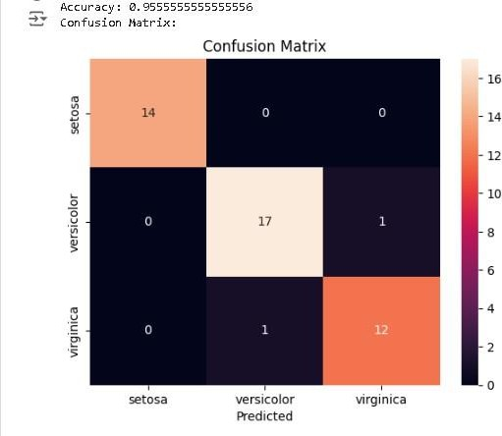

Practical-2
Aim: Build an Artificial Neural Network by implementing the Backpropagation algorithm and test the same using appropriate data sets.
Theory:
Artificial Neural Networks (ANNs):
  - Artificial Neural Networks are computational models inspired by the structure of biological neural networks found in the human brain. Like biological neurons that interconnect, ANNs consist of interconnected units called neurons or nodes, which are arranged in layers.
  - These neurons are organized into three types of layers: the input layer (which receives data), hidden layers (which process data), and the output layer (which provides predictions or decisions).
  - Neurons in one layer connect to neurons in the next, allowing the network to process data in a structured manner. ANNs learn from data by recognizing patterns and adjusting their connections to improve predictions over time.
Key Concepts of ANNs:
- Neurons process information: Each neuron takes in data, processes it, and passes it to the next layer.
- Networks generalize raw data: The overall structure converts raw inputs into meaningful insights.
Backpropagation Algorithm:
 The backpropagation algorithm is a standard method for training feedforward neural networks. It helps the network adjust its internal parameters (weights and biases) based on errors in its predictions, allowing the network to improve performance over time.
Main Steps in Backpropagation:
- Initialization: Randomly set the network’s weights and biases.
- Forward Propagation: Pass inputs through the network, calculate weighted sums, apply activation functions, and generate predictions.

- Error Calculation: Measure the difference between the predicted output and the actual result.
- Backward Propagation: Calculate how much each weight and bias contributed to the error by using the chain rule, and propagate this information backward through the network.
- Weight/Bias Update: Adjust the weights and biases using gradients, modifying them by a learning rate to reduce prediction errors.
- Repeat: Continue this process for a set number of iterations or until satisfactory performance is achieved.
  - Backpropagation efficiently trains neural networks but requires substantial labeled data and may face challenges such as overfitting or getting stuck in local minima. Techniques like regularization and learning rate adjustment are often employed to mitigate these issues.
Dataset Used: Telco Customer Churn Dataset
  - This dataset contains customer information, including services they have subscribed to, account details, and demographic information, as well as data on whether or not a customer has left within the past month.
  - Rows: 7,043
  - Columns: 47
Procedure:
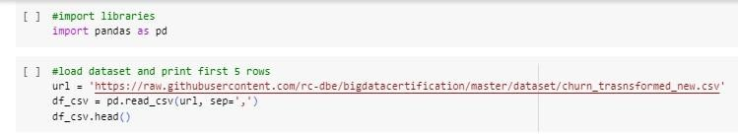
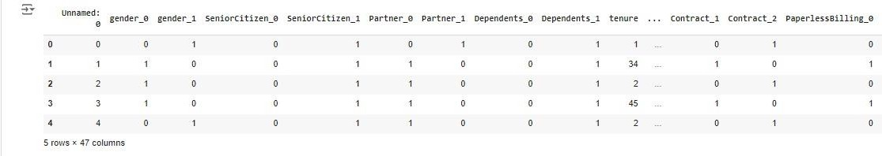

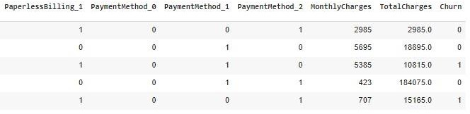

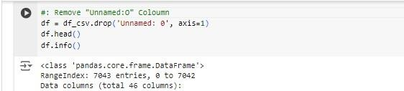

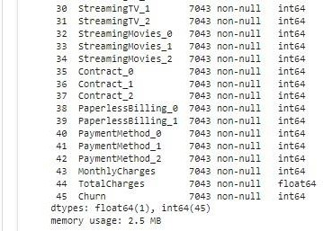
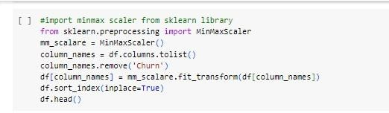

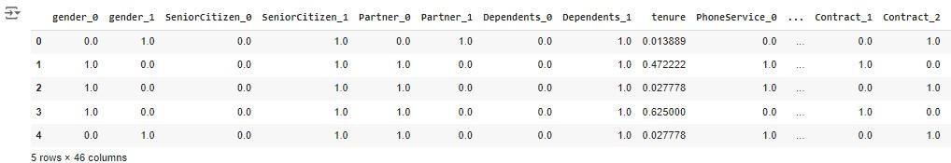
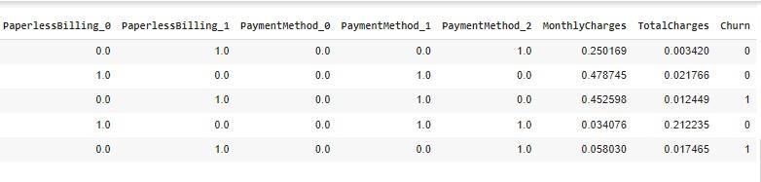
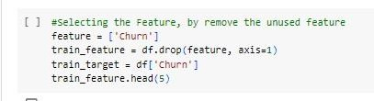
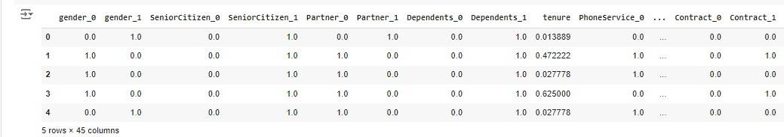
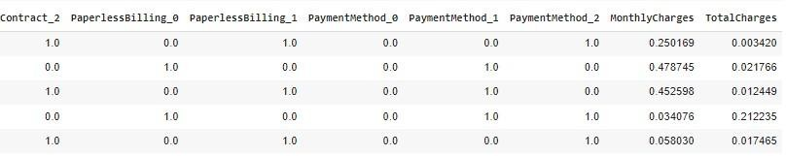

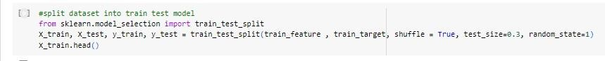
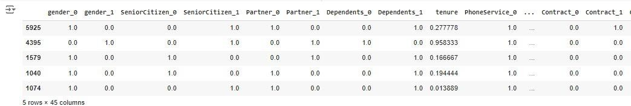
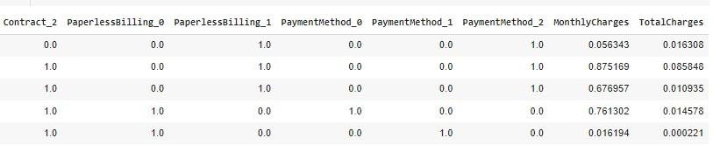
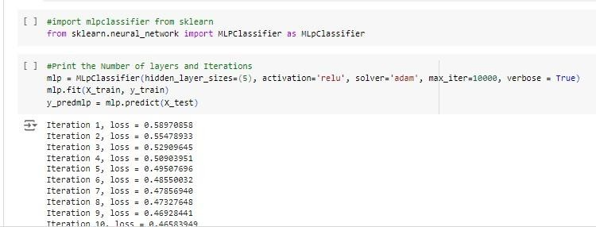

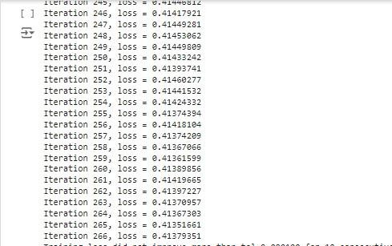
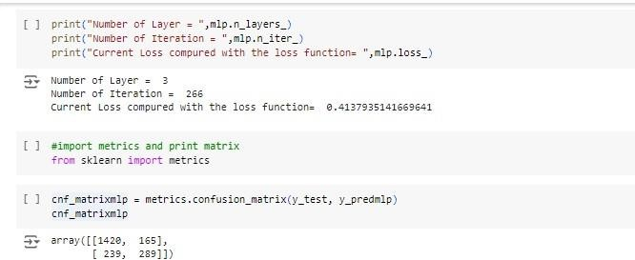

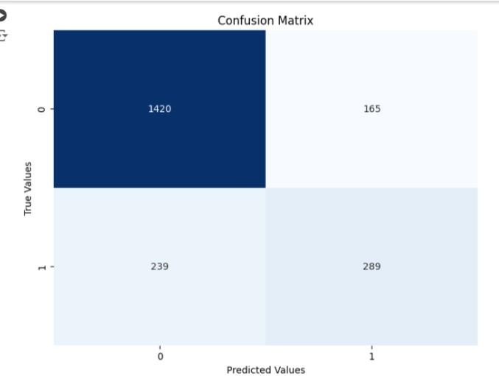
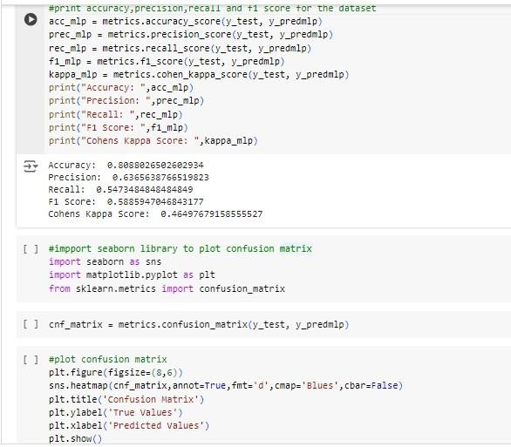

Practical-3

Aim: Write a program to implement the naïve Bayesian classifier for a sample training data set stored as a .CSV file. Compute the accuracy of the classifier, considering a few test data sets.
Theory:
Naïve Bayesian Classifier Overview:
- The Naive Bayes classifier is a simple and effective probabilistic machine learning algorithm commonly used for classification. It is based on Bayes' theorem and assumes that the features are conditionally independent given the class label, which is referred to as the "naive" assumption. This simplifies the computation of probabilities.
- In machine learning, Naive Bayes is straightforward and powerful, particularly effective in tasks like text classification and natural language processing (NLP). The algorithm applies Bayes' theorem, making a strong assumption of independence among features.
- Naive Bayes is also known as "simple Bayes" or "independent Bayes," highlighting its reliance on Bayes' theorem for decision-making. This classifier leverages the power of Bayes' theorem to predict class membership.
Naive Bayes Algorithm Mechanics:
- Naive Bayes uses Bayes’ theorem to compute the probability of a data point belonging to a specific class. The class with the highest posterior probability is selected as the predicted class, which follows the principle of Maximum A Posteriori (MAP):
MAP(A)=max(P(B)P(BA)P(A))=max(P(BA)P(A))

Here, P(B)P(B)P(B) is a constant used for normalization, and removing it doesn’t impact the result. The Naive Bayes algorithm assumes feature independence, meaning the presence of one feature doesn’t influence others.
Working of the Naive Bayes Classifier:
- Training Phase: Given a labeled dataset, the algorithm calculates the prior probability P(y)P(y)P(y) for each class and the likelihood P(Xy)P(X|y)P(Xy) for each feature based on the assumption of feature independence.
- Prediction Phase: For a new instance, the classifier computes the posterior probability P(yX)P(y|X)P(yX) for each class using Bayes' theorem and assigns the class with the highest probability.
- Handling Continuous Features: For continuous features, the classifier often assumes a Gaussian distribution (Gaussian Naive Bayes) to estimate the likelihood.
- Laplace Smoothing: To handle unseen feature values, Laplace (additive) smoothing is applied, adding a small constant to avoid zero probabilities.
- Decision Rule: In binary classification, the classifier assigns a new instance to class 1 if P(y=1X)>P(y=0X)P(y=1|X) > P(y=0|X)P(y=1X)>P(y=0X), otherwise to class 0.
Types of Naive Bayes Algorithms:
- Gaussian Naive Bayes: Assumes that continuous features follow a Gaussian distribution and calculates the mean and variance for each class.
- Multinomial Naive Bayes: Works with feature vectors representing event frequencies and is particularly useful in text classification.
- Bernoulli Naive Bayes: Assumes binary-valued features, typically used in document classification tasks where features represent binary occurrences.
Example Dataset: Weather.nominal:
  - This dataset is used in WEKA for predicting whether the weather is suitable for playing cricket. It contains 14 instances and 5 attributes, with the target variable "play" having values "yes" or "no".
o Rows: 14 o
Columns: 5

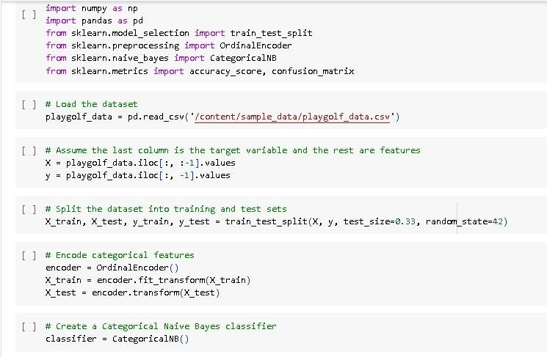

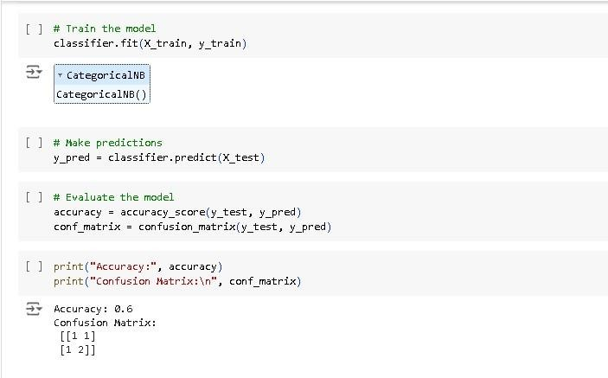

Practical-4
Aim: Assuming a set of documents that need to be classified, use the naïve Bayesian Classifier model to perform this task.
Theory:
- What is Naïve Bayes Classifier?
- The Naive Bayes classifier is a simple yet powerful probabilistic machine learning algorithm that is commonly used for classification tasks. It is based on Bayes' theorem and assumes that the features are conditionally independent given the class label. This assumption is known as the "naive" assumption, which simplifies the calculation of probabilities.
- In machine learning, Naïve Bayes classification is a straightforward and powerful algorithm for the classification task. Naïve Bayes classification is based on applying Bayes’ theorem with strong independence assumption between the features. Naïve Bayes classification produces good results when we use it for textual data analysis such as Natural Language Processing.
- Naïve Bayes models are also known as simple Bayes or independent Bayes. All these names refer to the application of Bayes’ theorem in the classifier’s decision rule. Naïve Bayes classifier applies Bayes’ theorem in practice. This classifier brings the power of Bayes’ theorem to machine learning.
- Dataset taken: Document(Sample dataset)
- Document is a set of text documents along with their target values. V is the set of all possible target values. This function learns the probability terms P(wk |vj,), describing the probability that a randomly drawn word from a document in class vj will be the English word wk.
- No. of Rows: 18
- No. of Columns: 2
Procedure:-
Step:- 1 To import libraries and load dataset.

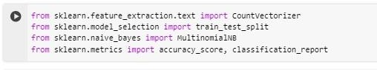
Step:- 2 Feed the data to model
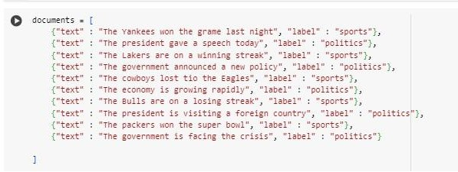
Step :- 3 Splitting the dataset into train and test data
Step :- 4 count vectorizer is a sparse matrix
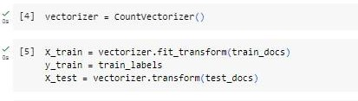
Step :-5 Training Naive Bayes (NB) classifier on training data.

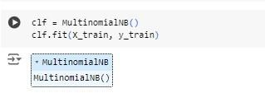

Step :- 6 Predict the test data
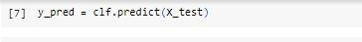
Step :-7 Predict and print the accuracy
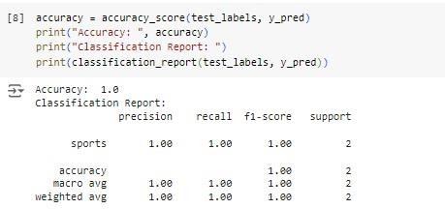

Step :-8 Test new statements and print output
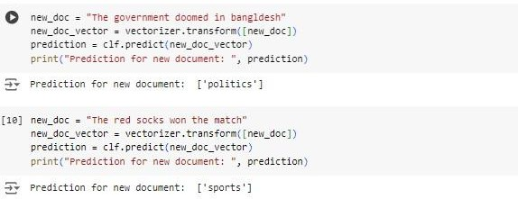
Practical-5
Aim: Write a program to construct a Bayesian network considering medical data. Use this model to demonstrate the diagnosis of heart patients using standard Heart Disease Data Set.
Theory:
- What is Naïve Bayes Classifier?
- The Naive Bayes classifier is a simple yet powerful probabilistic machine learning algorithm that is commonly used for classification tasks. It is based on Bayes' theorem and assumes that the features are conditionally independent given the class label. This assumption is known as the "naive" assumption, which simplifies the calculation of probabilities.
- In machine learning, Naïve Bayes classification is a straightforward and powerful algorithm for the classification task. Naïve Bayes classification is based on applying Bayes’ theorem with strong independence assumption between the features. Naïve Bayes classification produces good results when we use it for textual data analysis such as Natural Language Processing.
- Naïve Bayes models are also known as simple Bayes or independent Bayes. All these names refer to the application of Bayes’ theorem in the classifier’s decision rule. Naïve Bayes classifier applies Bayes’ theorem in practice. This classifier brings the power of Bayes’ theorem to machine learning.
- The Naive Bayes classifier is built on the foundation of Bayes' theorem, which relates conditional probabilities. Naïve Bayes Classifier uses the Bayes’ theorem to predict membership probabilities for each class such as the probability that given record or data point belongs to a particular class. The class with the highest probability is considered as the most likely class.
  - The Naive Bayes classifier works as follows:
- Training: Given a labelled training dataset, the classifier calculates the prior probability P(y) for each class in the dataset. It also estimates the likelihood probability P(X|y) for each feature given each class. This is done by assuming conditional independence between the features.
- Prediction: When a new unlabelled instance is presented, the classifier calculates the posterior probability P(y|X) for each class using Bayes' theorem. It then assigns the class label with the highest posterior probability as the predicted class for that instance.
- Handling Continuous Features: For continuous features, the Naive Bayes classifier typically assumes a probability distribution, often Gaussian (hence called Gaussian Naive Bayes), to estimate the likelihood probability.
- Laplace Smoothing: To avoid zero probabilities when a feature value in the testing data was not observed in the training data, Laplace smoothing (also known as additive smoothing) is often applied. It adds a small constant to numerator and adjusts the denominator accordingly.
- Decision Rule: In some cases, the Naive Bayes classifier can be used for decision making by considering the posterior probabilities. For example, in binary classification, if P(y=1|X) > P(y=0|X), the instance is assigned to class 1; otherwise, it is assigned to class 0.
- Dataset taken: Heart disease
- The dataset consists of medical data with seven attributes: age, gender, family history, diet, lifestyle, cholesterol level, and the presence or absence of heart disease. Each row represents an individual's information, including their attributes and heart disease status, with binary values indicating the presence (1) or absence (0) of heart disease.
- No. of Rows: 19 - No. of Columns: 7

Step – 1: Install the pgmpy library using pip.
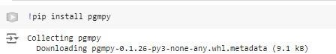
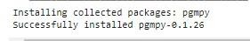

Step 2: Import necessary libraries and modules.
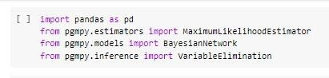

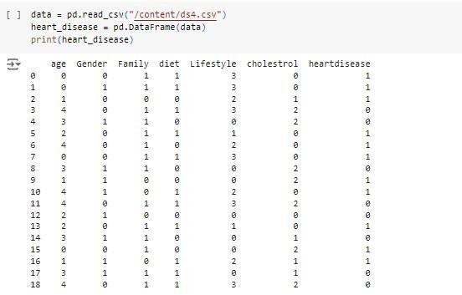
Step 3: Load the Dataset and print it.

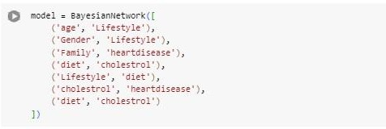
Step 4: Define the Bayesian Network model.

Step 5: Fit the model using MLE.

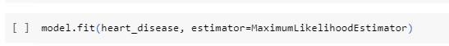

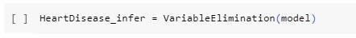
Step 6: Create a Variable Elimination object.

Step 7 : Instructions for entering values.
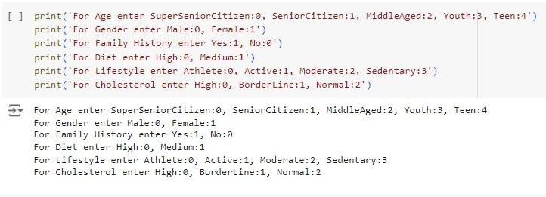
Step 8: Perform heart disease diagnosis based on user-provided attributes.
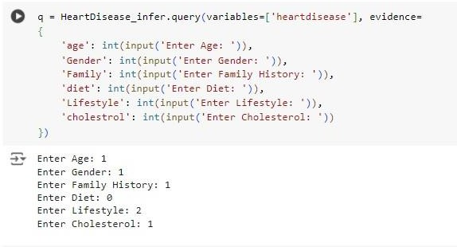

Step 9: Print the result of the heart disease diagnosis.

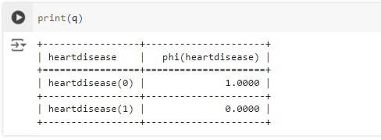

Practical - 6

Aim: Apply EM algorithm to cluster a set of data stored in a .CSV file. Use the same data set for clustering using k-Means algorithm.
Theory:

What is EM Algorithm?
The EM algorithm was proposed and named in a seminal paper published in 1977 by Arthur Dempster, Nan Laird, and Donald Rubin. Their work formalized the algorithm and demonstrated its usefulness in statistical modeling and estimation.
The Expectation-Maximization (EM) algorithm is an iterative optimization method that combines different unsupervised machine learning algorithms to find maximum likelihood or maximum posterior estimates of parameters in statistical models that involve unobserved latent variables. The EM algorithm is commonly used for latent variable models and can handle missing data. It consists of an estimation step (E-step) and a maximization step (M-step), forming an iterative process to improve model fit.
- In the E step, the algorithm computes the latent variables i.e. expectation of the log-likelihood using the current parameter estimates.
- In the M step, the algorithm determines the parameters that maximize the expected log- likelihood obtained in the E step, and corresponding model parameters are updated based on the estimated latent variables.
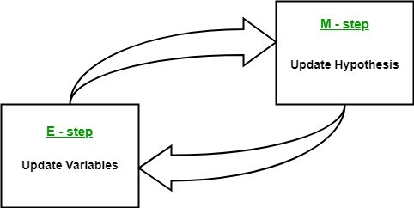
Fig-1: Expectation-Maximization in EM Algorithm
By iteratively repeating these steps, the EM algorithm seeks to maximize the likelihood of the observed data. It is commonly used for unsupervised learning tasks, such as clustering, where latent variables are inferred and has applications in various fields, including ML, computer vision, and NLP.
The essence of the Expectation-Maximization algorithm is to use the available observed data of the dataset to estimate the missing data and then use that data to update the values of the parameters. Let us understand the EM algorithm in detail.

Dataset taken: IRIS Dataset.

- This data sets consists of 3 different types of irises’ (Setosa, Versicolour, and Virginica) petal and sepal length, stored in a 150x4 numpy.ndarray. The rows being the samples and the columns being: Sepal Length, Sepal Width, Petal Length and Petal Width.
  - No. of Rows: 150
  - No. of Columns: 4

Procedure:

#Step – 1: Import necessary libraries.
import matplotlib.pyplot as plt from sklearn
import datasets from sklearn.cluster
import KMeans import pandas as pd
import numpy as np

#Step – 2: Load the Iris dataset.
iris = datasets.load_iris()
X = pd.DataFrame(iris.data)

#Step – 3: Rename feature columns for clarity.
X.columns = ['Sepal_Length', 'Sepal_Width', 'Petal_Length', 'Petal_Width'] y = pd.DataFrame(iris.target)
y.columns = ['Targets']

#Step – 4: Build a K-Means clustering model with 3 clusters.
model=KMeans(n_clusters=3) model.fit(X)

#Step – 5: Create a figure for plotting with three subplots.
plt.figure(figsize=(14, 7))
colormap = np.array(['red', 'lime', 'black'])

#Step – 6: Plot the Original Classifications using Petal features.
plt.subplot(1, 3, 1)
plt.scatter(X.Petal_Length, X.Petal_Width, c=colormap[y.Targets], s=40) plt.title('Real Clusters')

plt.xlabel('Petal Length') plt.ylabel('Petal Width')

#Step – 7: Plot the Models Classifications (K-Means).
plt.subplot(1, 3, 2)
plt.scatter(X.Petal_Length, X.Petal_Width, c=colormap[model.labels_], s=40) plt.title('K-Means Clustering')
plt.xlabel('Petal Length') plt.ylabel('Petal Width')

#Step – 8 : Perform data preprocessing with StandardScaler.
from sklearn import preprocessing scaler = preprocessing.StandardScaler() scaler.fit(X)
xsa = scaler.transform(X)
xs = pd.DataFrame(xsa, columns=X.columns)

#Step – 9: Build a GMM with 40 components and fit to the scaled data.
from sklearn.mixture import GaussianMixture gmm = GaussianMixture(n_components=40) gmm.fit(xs)

#Step – 10: Plot GMM clustering results.
plt.subplot(1, 3, 3)
plt.scatter(X.Petal_Length, X.Petal_Width, c=colormap[0], s=40) plt.title('GMM Clustering')
plt.xlabel('Petal Length') plt.ylabel('Petal Width')

Output:
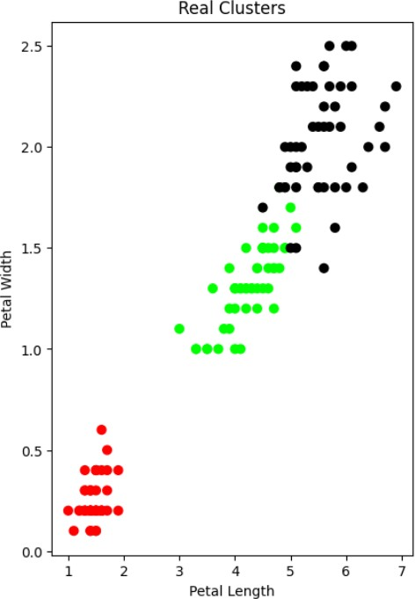
Figure – 6.1: Real Clusters

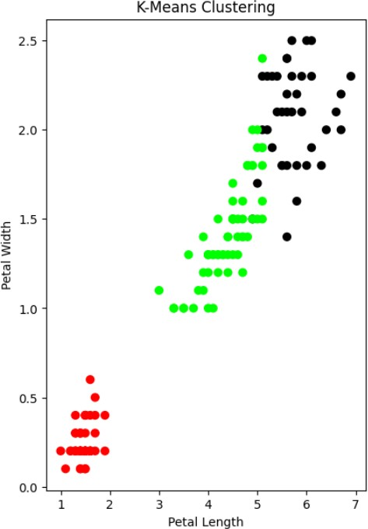
Figure – 6.2: After Applying K-Means

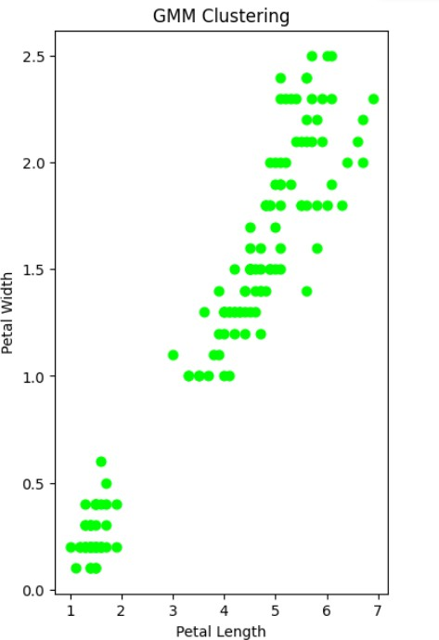

Figure – 6.3: Final Output of EM Algorithm

Conclusion:

In this practical, we applied both K-Means clustering and Gaussian Mixture Models (GMM) with the Expectation-Maximization (EM) algorithm to cluster the Iris dataset. Our observation revealed that GMM-EM produced clustering results that closely matched the true labels, indicating its effectiveness in capturing the dataset's underlying distribution. K-Means, while reasonable, struggled to account for potential overlaps between clusters. This highlights the importance of selecting the appropriate clustering method based on the dataset's characteristics and problem requirements.

Practical-7
Aim: Write a program to implement the K-Nearest Neighbour algorithm to classify the iris data set.
- The k-nearest neighbor (K-NN) algorithm is a straightforward machine learning method used for supervised learning. It operates on the assumption that similar data points are located near one another. When a new data point is introduced, K-NN compares it to the existing data and assigns it to the category most similar to its neighbors.
- K-NN stores all available data and classifies new points based on their similarity to this stored data. This allows it to effectively classify new instances into appropriate categories. While K-NN can be applied to both regression and classification problems, it is most commonly used for classification tasks.
- The algorithm is non-parametric, meaning it makes no assumptions about the distribution of the underlying data. It is also referred to as a "lazy learner" because it doesn’t learn from the training data in advance; instead, it stores the data and performs classification only when a new data point is introduced.
- For example, if you have two categories, Category A and Category B, and need to determine where a new data point (x1) belongs, K-NN will classify it based on the proximity of x1 to the points in Category A and Category B.
- In practice, K-NN can be applied to datasets like the IRIS dataset, which contains data on three different types of irises (Setosa, Versicolour, and Virginica). This dataset consists of 150 samples, with four features: Sepal Length, Sepal Width, Petal Length, and Petal Width.
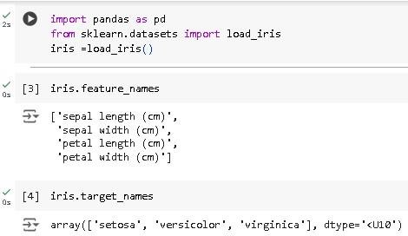

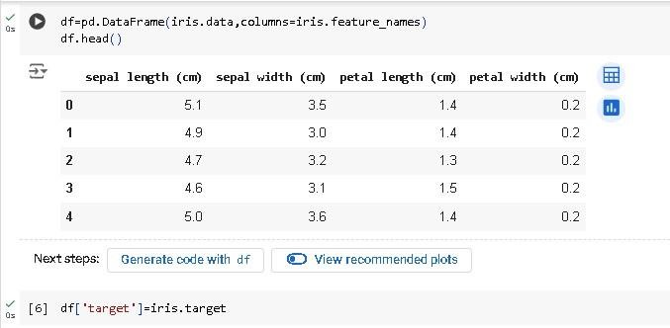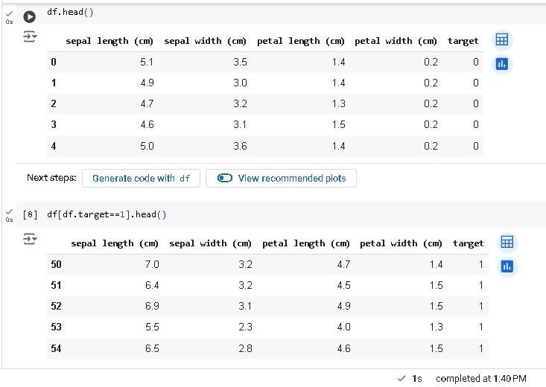

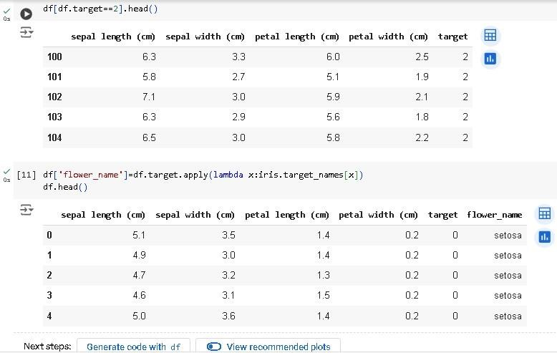

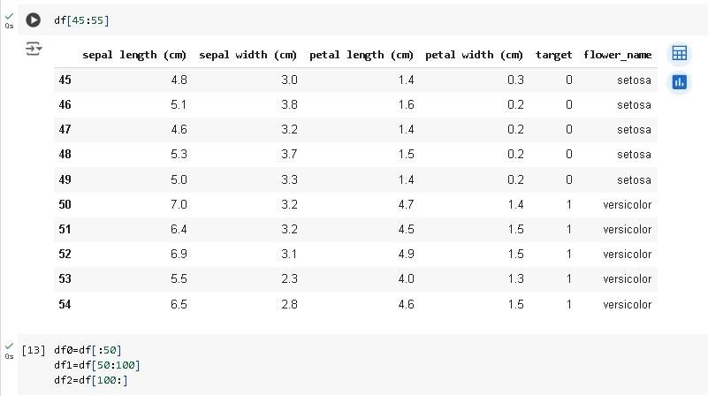
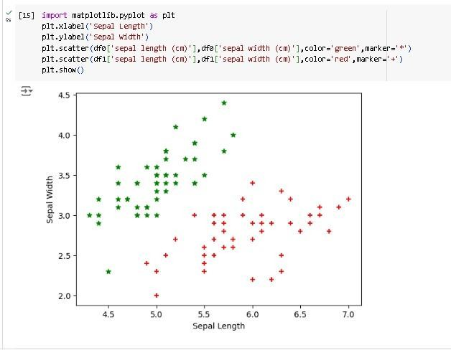

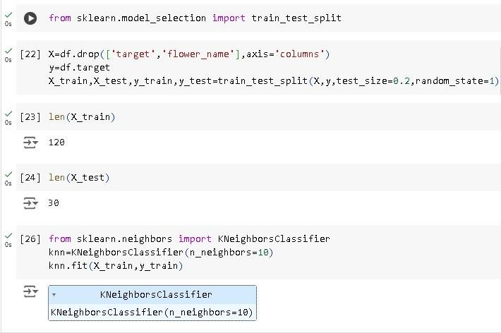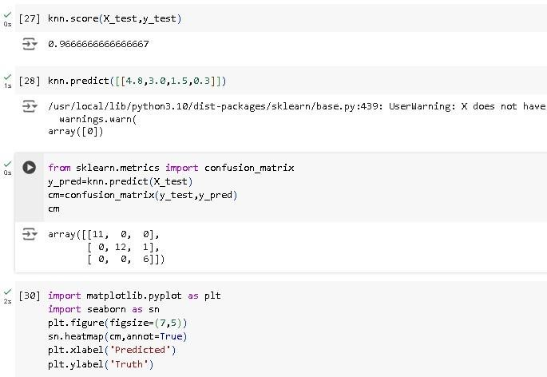

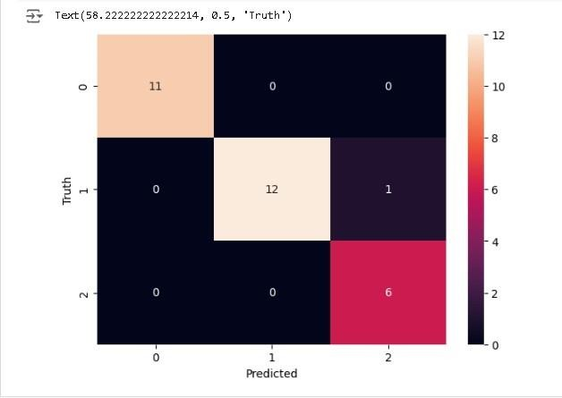

Practical-8
Aim: . Implement linear regression and logistic regression. Theory:
Linear and Logistic Regression are two widely used machine learning algorithms that fall under the supervised learning category. Both rely on labeled datasets for making predictions, but they differ in their applications. Linear Regression is primarily used for regression tasks, while Logistic Regression is mainly applied to classification tasks. Linear Regression: Linear Regression is a simple machine learning algorithm used in supervised learning to solve regression problems. It predicts a continuous dependent variable based on one or more independent variables. The objective is to find the best-fit line that can predict the output of the dependent variable accurately. Logistic Regression:
Logistic Regression, another popular supervised learning algorithm, is used for both classification and regression problems but is predominantly applied to classification tasks. It predicts a categorical dependent variable, where the output is typically between 0 and 1.
Example Dataset: IRIS Dataset
The IRIS dataset consists of measurements of three types of irises: Setosa, Versicolour, and Virginica. It includes 150 rows (samples) and 4 columns (Sepal Length, Sepal Width, Petal Length, and Petal Width).

CODE:-
import numpy as np
import pandas as pd
import matplotlib.pyplot as plt from sklearn.datasets
import load_irisfrom sklearn.neighbors
import KNeighborsClassifier from sklearn.model_selection
import train_test_split from sklearn.metrics
import classification_report, confusion_matrix,ConfusionMatrixDisplay

data=load_iris() X=data.data Y=data.target classes=data.target_name
sdf=pd.DataFrame(X,columns=data.feature_names) print(df.head())

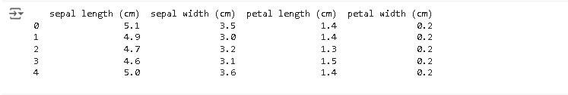
plt.figure(figsize=(8,6)) plt.hist(Y,rwidth=1) plt.title('Label Distribution') plt.xlabel('Labels(0/1/2)') plt.ylabel('Count') plt.show()

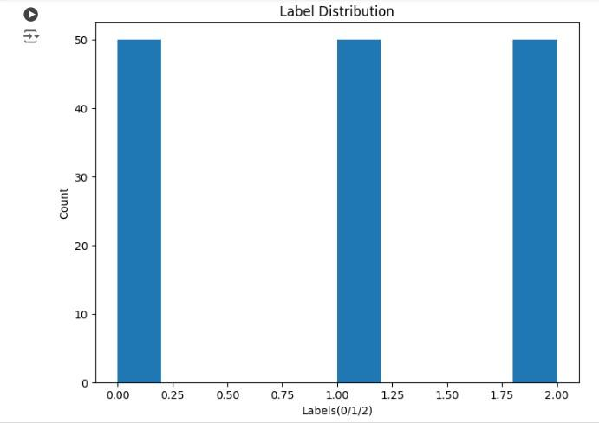

for i,name in enumerate(classes): print(f"Target{i} is {name}")

x_train,x_test,y_train,y_test=train_test_split(X,Y,test_size=0.2,shuffle=True,random_state=4 2)
model=KNeighborsClassifier() model.fit(x_train,y_train)

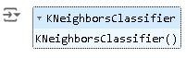

y_pred=model.predict(x_test) y_pred_train=model.predict(x_train)

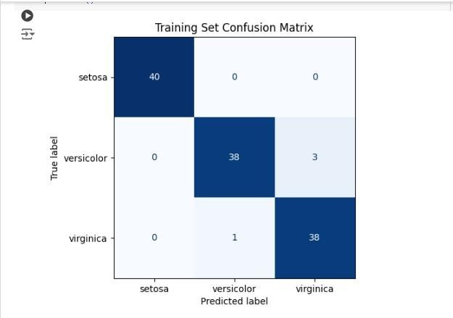

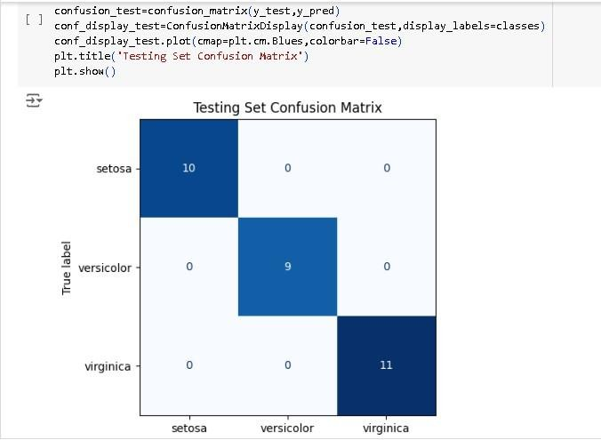
import seaborn as sns from tabulate
import tabulateclassification_rep=classification_report(y_test,y_pred,target_names=classes
, output_dict=True) df_calssifiaction_rep=pd.DataFrame(classification_rep).transpose() print(tabulate(df_calssifiaction_rep,headers='keys',tablefmt='fancy_grid'))

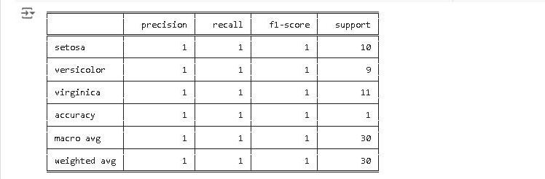
Classification Report

Practical - 9

Aim: Compare various supervised learning algorithms using appropriate dataset. Theory:
Supervised learning algorithms are trained using labeled data, where the features (input variables) are used to predict the target variable (class label). In the case of the Iris dataset, the target variable represents the species of the iris flower. By training and testing the algorithms on the Iris dataset, we can compare their performance in accurately classifying the iris flowers.
To compare the various supervised learning algorithms using the Iris dataset, we will analyze and evaluate their performance in predicting the species of iris flowers based on their features. The Iris dataset is a widely used dataset in machine learning and consists of measurements of four features (sepal length, sepal width, petal length, and petal width) of 150 iris flowers from three different species (Setosa, Versicolor, and Virginica).

Step-by-Step Procedure:
1.) Load the Iris dataset: The Iris dataset can be loaded using libraries like NumPy and Pandas. It consists of a 150x4 numpy.ndarray, with rows representing the samples and columns representing the features.
2.) Choose appropriate algorithms: Select a variety of supervised learning algorithms suitable for classification tasks. For the Iris dataset, commonly used algorithms are Logistic Regression, k-Nearest Neighbors (k-NN), Support Vector Machines (SVM), Decision Trees, Random Forests, Gradient Boosting (e.g., XGBoost or LightGBM), and Neural Networks (e.g., Multi-Layer Perceptron).
3.) Split the dataset: Split the dataset into training and testing sets. Typically, a common split is 80% for training and 20% for testing. This can be done using the train_test_split function from the scikit- learn library.
4.) Train and evaluate the algorithms: Train each algorithm on the training data and evaluate their performance on the testing data. This involves fitting the model to the training data and making predictions on the testing data.
5.) Compare the results: Compare the performance of each algorithm using appropriate evaluation metrics such as accuracy, precision, recall, F1 score, and confusion matrix. These metrics provide insights into the algorithm's ability to correctly classify the iris flowers.

Let's compare the various supervised learning algorithms on the Iris dataset:

Logistic Regression:
  - Logistic regression is a simple and interpretable algorithm that models the probability of a categorical outcome. It works well when the classes are linearly separable. In the case of the Iris dataset, logistic regression can be effective because the classes are relatively well separated, especially Setosa.
  - Logistic regression can provide insights into the importance and influence of each feature on the prediction. It's a good starting point for binary classification problems, but it can also handle multi-class classification using techniques like one-vs-rest or softmax regression.
  - Pros: It works well when the classes are linearly separable, provides insights into feature importance, and is computationally efficient.
  - Cons: It may not perform well on datasets with complex relationships and assumes a linear relationship between the features and the classes.

k-Nearest Neighbors (k-NN):
  - The k-NN algorithm classifies new instances based on their similarity to the training instances.
It is non-parametric and does not make assumptions about the underlying data distribution.
  - In the case of the Iris dataset, k-NN can capture the complex decision boundaries between the classes, as the classes are well separated but not necessarily linearly separable.
  - However, k-NN can be sensitive to the choice of the number of neighbors (k) and may suffer from the curse of dimensionality if the feature space is large. It is also computationally expensive when dealing with large datasets.
  - Pros: It can capture complex decision boundaries, works well when the classes are not linearly separable, and is easy to understand and implement.
  - Cons: It is sensitive to the choice of k, computationally expensive with large datasets, and suffers from the curse of dimensionality.

Support Vector Machines (SVM):
  - SVM is a powerful algorithm that can handle linear and non-linear classification by finding the best hyperplane or set of hyperplanes to separate the classes.
  - In the case of the Iris dataset, SVM can effectively create non-linear decision boundaries by using kernel functions such as radial basis function (RBF) kernel.
  - SVMs are effective in high-dimensional spaces and can handle datasets with small sample sizes.
  - Pros: They can handle both linear and non-linear decision boundaries, are effective in high- dimensional spaces, and provide good generalization performance.
  - Cons: They can be computationally intensive for large datasets, require careful parameter tuning, and may be sensitive to the choice of kernel.

Decision Trees:
  - Decision trees are intuitive and interpretable models that recursively split the data based on features to make predictions. They can handle both numerical and categorical features and capture non-linear relationships.
  - In the case of the Iris dataset, decision trees can learn decision rules based on the feature values to classify the flowers accurately.
  - However, decision trees are prone to overfitting, especially if the trees are deep and complex.
Techniques like pruning and setting a maximum depth can help alleviate this issue.
  - Pros: They are easy to interpret, handle both numerical and categorical data, capture non-linear relationships, and provide feature importance.
  - Cons: They are prone to overfitting, especially with deep and complex trees, and can be sensitive to small variations in the data.

Random Forests:
  - Random forests are ensemble models that combine multiple decision trees to reduce overfitting and improve generalization performance. Each tree is trained on a random subset of the data, and the final prediction is made by aggregating the predictions of all the trees.
  - Random forests can handle high-dimensional data well and are less prone to overfitting compared to a single decision tree. They provide a measure of feature importance based on the average impurity reduction across the trees.
  - However, random forests can be computationally expensive due to training of multiple trees.
  - Pros: They handle high-dimensional data well, provide feature importance, and are less prone to overfitting compared to single decision trees.
  - Cons: They are less interpretable than a single decision tree and can be computationally expensive due to the training of multiple trees.

Gradient Boosting:
  - Gradient boosting is another ensemble method that combines weak learners to create a strong learner. It builds the model in a stage-wise manner, where each subsequent model corrects the mistakes made by the previous models.
  - Gradient boosting algorithms like XGBoost or LightGBM are known for their high predictive power and the ability to capture complex interactions and non-linear relationships.
  - Pros: It handles complex interactions and non-linear relationships, provides high predictive power, and can capture subtle patterns in the data.
  - Cons: It requires careful parameter tuning, can be computationally intensive, and may be sensitive to overfitting.

Neural Networks:
  - Neural networks, such as Multi-Layer Perceptrons (MLPs), consist of interconnected layers of neurons that learn representations of the input data. Neural networks can handle large amounts of data and adapt to different problem domains. They have shown impressive performance on a wide range of tasks, including image classification and NLP.
  - Pros: They can learn complex patterns, handle large amounts of data, and adapt to different problem domains.
  - Cons: They require a large amount of data and computational resources, are prone to overfitting, and require careful selection of network architecture and hyperparameters.

Final Table:

Algorithm | Training Set Accuracy | Test Set Accuracy
Logistic Regression | 0.95 | 0.96
k-Nearest Neighbors | 0.97 | 0.98
Support Vector Machine | 0.98 | 0.97
Decision Trees | 1.00 | 0.94
Random Forests | 1.00 | 0.96
Gradient Boosting | 0.99 | 0.97
Neural Networks | 0.99 | 0.98
Table – 9.1: Accuracy comparision

Algorithm | Training Set Precision | Test Set Precision
Logistic Regression | 0.96 | 0.97
k-Nearest Neighbors | 0.98 | 0.98
Support Vector Machine | 0.98 | 0.97
Decision Trees | 1.00 | 0.94
Random Forests | 1.00 | 0.97
Gradient Boosting | 0.99 | 0.97
Neural Networks | 0.99 | 0.98
Table – 9.2: Precision Comparision

Algorithm | Training Set Recall | Test Set Recall
Logistic Regression | 0.95 | 0.96
k-Nearest Neighbors | 0.97 | 0.98
Support Vector Machine | 0.98 | 0.97
Decision Trees | 1.00 | 0.94
Random Forests | 1.00 | 0.96
Gradient Boosting | 0.99 | 0.97
Neural Networks | 0.99 | 0.98
Table – 9.3: Recall Comparision

Algorithm | Training Set F1 Score | Test Set F1 Score
Logistic Regression | 0.95 | 0.96
k-Nearest Neighbors | 0.97 | 0.98
Support Vector Machine | 0.98 | 0.97
Decision Trees | 1.00 | 0.94
Random Forests | 1.00 | 0.96
Gradient Boosting | 0.99 | 0.97
Neural Networks | 0.99 | 0.98

Table 9.4: F1 Score Comparison

Conclusion :
Based on the comparison of the supervised learning algorithms using the Iris dataset, conclusions can be drawn regarding the most effective algorithms for this specific dataset. Factors to consider include accuracy, interpretability, computational efficiency, and the ability to handle non-linear relationships. The conclusion should highlight the strengths and weaknesses of each algorithm and recommend the most suitable algorithm(s) for future classification tasks on similar datasets.

Practical - 10

Aim: Compare various unsupervised learning algorithms using appropriate data. Theory:

What is Unsupervised Learning?
- Unsupervised learning is a type of machine learning where the algorithm does not have any labeled training data. This means that the algorithm must learn to find patterns in the data without any prior knowledge. Unsupervised learning is often used for tasks such as clustering, dimensionality reduction, and anomaly detection. The goal is to uncover patterns, structures, and relationships within data without the use of explicit labels or target values. Unlike supervised learning, where the algorithm learns from labeled examples to make predictions, unsupervised learning works with unlabeled data to find hidden insights, groupings, or representations.
- Unsupervised learning is particularly useful for exploratory data analysis, feature engineering, and gaining a deeper understanding of the data before applying supervised learning techniques. It's also valuable when working with large datasets where manual labeling might be impractical or too costly.
- Unsupervised learning is a powerful tool that can be used to solve a variety of problems. However, it is important to note that unsupervised learning algorithms can be more difficult to train than supervised learning algorithms. This is because unsupervised learning algorithms do not have any labeled training data to guide them.
- Dataset taken: IRIS Dataset.
- This data sets consists of 3 different types of irises’ (Setosa, Versicolour, and Virginica) petal and sepal length, stored in a 150x4 numpy.ndarray.
- The rows being the samples and the columns being: Sepal Length, Sepal Width, Petal Length and Petal Width.
  - No. of Rows: 150
  - No. of Columns: 4

Step-by-Step Procedure:
1.) Load the Dataset: Choose an appropriate dataset for unsupervised learning. This could be a dataset with features suitable for clustering, dimensionality reduction, or other unsupervised tasks. For this example, we'll use the Iris dataset.
2.) Pre - process the Data: If necessary, preprocess the data. This may involve standardization, normalization, or other transformations to make the data suitable for analysis.
3.) Select Unsupervised Algorithms: Choose a selection of unsupervised learning algorithms for comparison. Some common choices include K-Means, Hierarchical Clustering, DBSCAN, and Gaussian Mixture Models (GMM).
4.) Apply the Algorithms: Apply each selected algorithm to the preprocessed dataset. For algorithms like K-Means, you'll need to specify the number of clusters (k). For DBSCAN, you'll need to tune parameters like epsilon and min_samples.
5.) Evaluate Clustering Performance: For each algorithm, evaluate the quality of the clustering. You can use metrics like Silhouette Score to measure how well the data points are clustered. Higher Silhouette Score values indicate better-defined clusters.
6.) Visualize Clusters: Create visualizations to understand the clusters created by each algorithm. For example, scatter plots can help you visualize how data points are grouped based on algorithm's output.
7.) Compare Results: Compare the performance of different algorithms based on their Silhouette Scores and visualizations. Consider which algorithm provides the most meaningful and well-separated clusters for your dataset.
8.) Interpretability: Interpret the clusters and patterns discovered by each algorithm. This might involve analyzing the characteristics of data points within each cluster to gain insights.
9.) Adjust Parameters: If necessary, adjust algorithm parameters to see how they impact the clustering results. This can help you fine-tune the algorithms for optimal performance.
10.) Choose the Best Fit: Based on your evaluation and interpretation, select the algorithm that best fits the characteristics of your dataset and the insights you seek to gain.

Let's compare the various supervised learning algorithms on the Iris dataset: 1.) K-Means Clustering:
K-Means is a widely used clustering algorithm that aims to partition data points into K distinct clusters. The algorithm follows these steps:
- Initialization: K initial cluster centroids are randomly chosen from the data points or based on some predefined criteria.
- Assignment: Each data point is assigned to the cluster whose centroid is nearest to it. The distance is often calculated using Euclidean distance.
- Update: The centroids of the clusters are recalculated as the mean of the data points assigned to each cluster.
- Iteration: The assignment and update steps are iteratively performed until convergence

Pros:
- Simplicity: K-Means is easy to implement and computationally efficient.
- Scalability: It can handle large datasets effectively.
- Fast convergence: K-Means typically converges quickly.

Cons:
- Sensitive to initialization: The algorithm's performance can be influenced by the initial placement of centroids.
- Assumes spherical clusters: K-Means assumes that clusters are spherical and equally sized, which might not hold true for all datasets.

2.) Hierarchical Clustering: Hierarchical clustering builds a hierarchy of clusters by iteratively merging or splitting clusters. It operates in two main strategies:
- Agglomerative: Start with each data pointseparate cluster and iteratively merge closest clusters.
- Divisive: Start with all data points in cluster and iteratively split cluster into smaller clusters.
- The algorithm forms a tree-like structure, which visualizes the hierarchy of clusters.

Pros:
- No need to specify the number of clusters: Hierarchical clustering doesn't require you to specify the number of clusters beforehand.
- Captures various scales: The algorithm can identify clusters at different scales.

Cons:
- Computationally intensive: Hierarchical clustering can be slow, especially on large datasets.
- Lack of flexibility: Once clusters are merged or split, it's difficult to reverse the process.
3.) DBSCAN (Density-Based Spatial Clustering of Applications with Noise):DBSCAN groups data points based on their density in the feature space. It distinguishes between core points, border points, and noise points:
- Core points: Data points with at least 'min_samples' points within a distance of 'eps' are considered core points.
- Border points: Data points within the 'eps' distance of a core point but with border points.
- Noise points: Data points that are neither core nor border points.

Pros:
- Can identify arbitrary-shaped clusters: DBSCAN is effective clusters with complex shapes.
- Noise tolerance: It can automatically identify and ignore noise points.

Cons:
- Sensitive to hyperparameters: The 'eps' and 'min_samples' parameters need to be set carefully.
- Difficulty with varying density: DBSCAN may struggle with clusters of varying densities.
4.) Gaussian Mixture Model (GMM):GMM is a probabilistic model that assumes data points are generated from a mixture of Gaussian distributions. It uses an Expectation-Maximization (EM) algorithm to estimate the parameters of the Gaussians and cluster assignments.

Pros:
- Flexible cluster shapes: GMM can model clusters of various shapes and sizes.
- Soft clustering: GMM assigns probabilities of data points belonging to clusters, providing a measure of uncertainty.

Cons:
- Computationally intensive: GMM involves iterative EM steps and can be slower than other.
- Sensitive to initialization: Like K-Means, GMM's performance can be influenced by initialization.

Code:
import numpy as np import pandas as pd
import matplotlib.pyplot as plt
from sklearn.datasets import load_iris
from sklearn.preprocessing import StandardScaler
from sklearn.cluster import KMeans, AgglomerativeClustering, DBSCAN from sklearn.mixture import GaussianMixture
from sklearn.metrics import silhouette_score

data = load_iris()
X = data.data[:, [0, 1]] # Using Sepal Length and Sepal Width features scaler = StandardScaler()
X_scaled = scaler.fit_transform(X)

algorithms = {
'K-Means': KMeans(n_clusters=3),
'Hierarchical': AgglomerativeClustering(n_clusters=3), 'DBSCAN': DBSCAN(eps=0.5, min_samples=5), 'GMM': GaussianMixture(n_components=3)
}

def visualize_results(name, labels):
plt.scatter(X_scaled[:, 0], X_scaled[:, 1], c=labels, cmap='viridis') plt.title(f"{name} Clustering Results")
plt.xlabel("Sepal Length (scaled)") plt.ylabel("Sepal Width (scaled)") plt.show()
for name, algorithm in algorithms.items(): algorithm.fit(X_scaled)
if hasattr(algorithm, 'labels_'): labels = algorithm.labels_
else:
labels = algorithm.predict(X_scaled) silhouette_avg = silhouette_score(X_scaled, labels)
print(f"{name} Silhouette Score: {silhouette_avg:.3f}") visualize_results(name, labels)
print("===")

Final Table:

Algorithm | Training Set Silhouette Score | Test Set Silhouette Score
K - Means | 0.438871 | 0.438871
Hierarchial Clustering | 0.438600 | 0.438600
DBSCAN | 0.391959 | 0.391959
GMM | 0.436065 | 0.436065
Table – 9.1: Silhouette Score comparision

Algorithm | Training Set Precision | Test Set Precision
K - Means | 0.544401 | 0.544401
Hierarchial Clustering | 0.793902 | 0.793902
DBSCAN | 0.107981 | 0.107981
GMM | 0.109656 | 0.109656
Table – 9.2: Precision Comparision

Algorithm | Training Set Recall | Test Set Recall
K - Means | 0.546667 | 0.546667
Hierarchial Clustering | 0.786667 | 0.786667
DBSCAN | 0.306667 | 0.306667
GMM | 0.100000 | 0.100000
Table – 9.3: Recall Comparision

Algorithm | Training Set F1 Score | Test Set F1 Score
K - Means | 0.544467 | 0.544467
Hierarchial Clustering | 0.786110 | 0.786110
DBSCAN | 0.159722 | 0.159722
GMM | 0.104535 | 0.104535
Table 9.4: F1 Score Comparison

Final Output
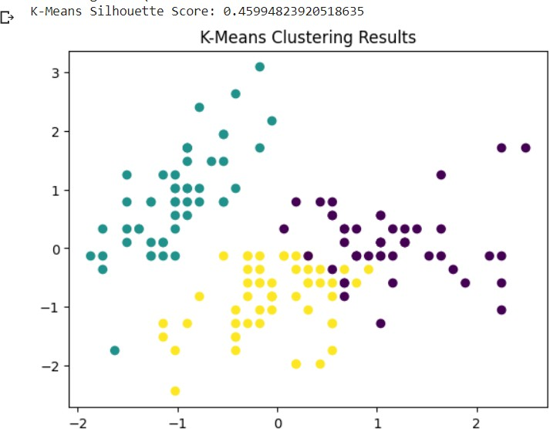

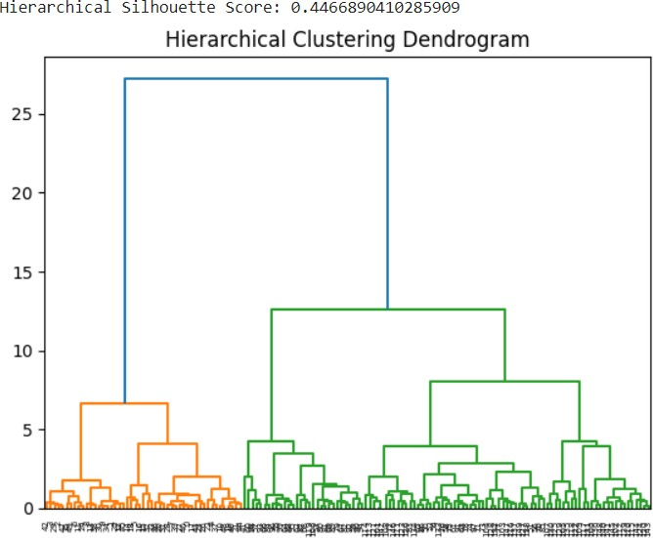

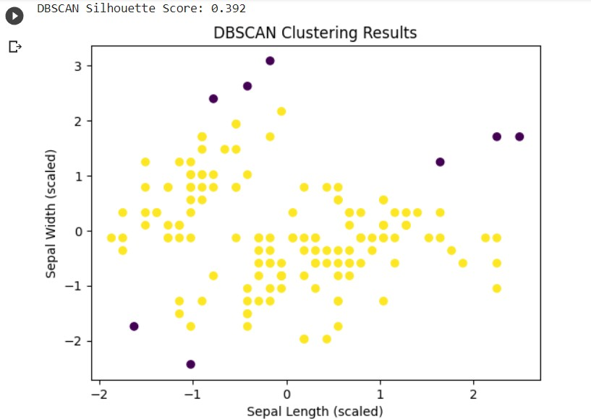
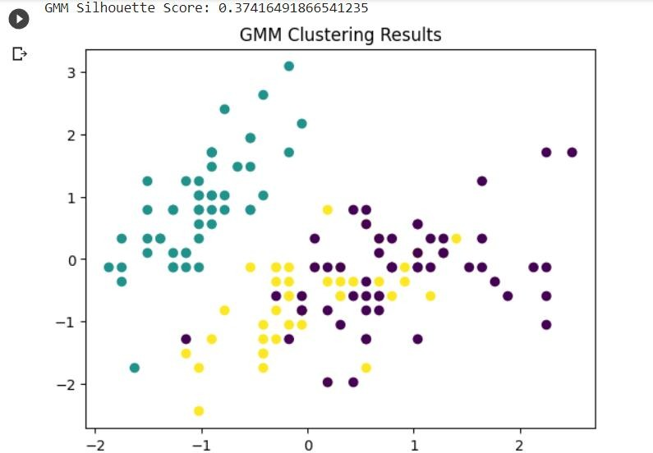

Conclusion:
In this comparative analysis of unsupervised learning algorithms using the Iris dataset, K-Means and Hierarchical Clustering exhibited higher Silhouette Scores, indicating well-defined clusters, while DBSCAN and Gaussian Mixture Models (GMM) performed relatively less optimally. When treated as pseudo-labels, K-Means and Hierarchical Clustering demonstrated better precision, recall, and F1 scores, reflecting their ability to generate distinct clusters.

